AHC BBQ

Task notes

### Recreate the design as a webpage

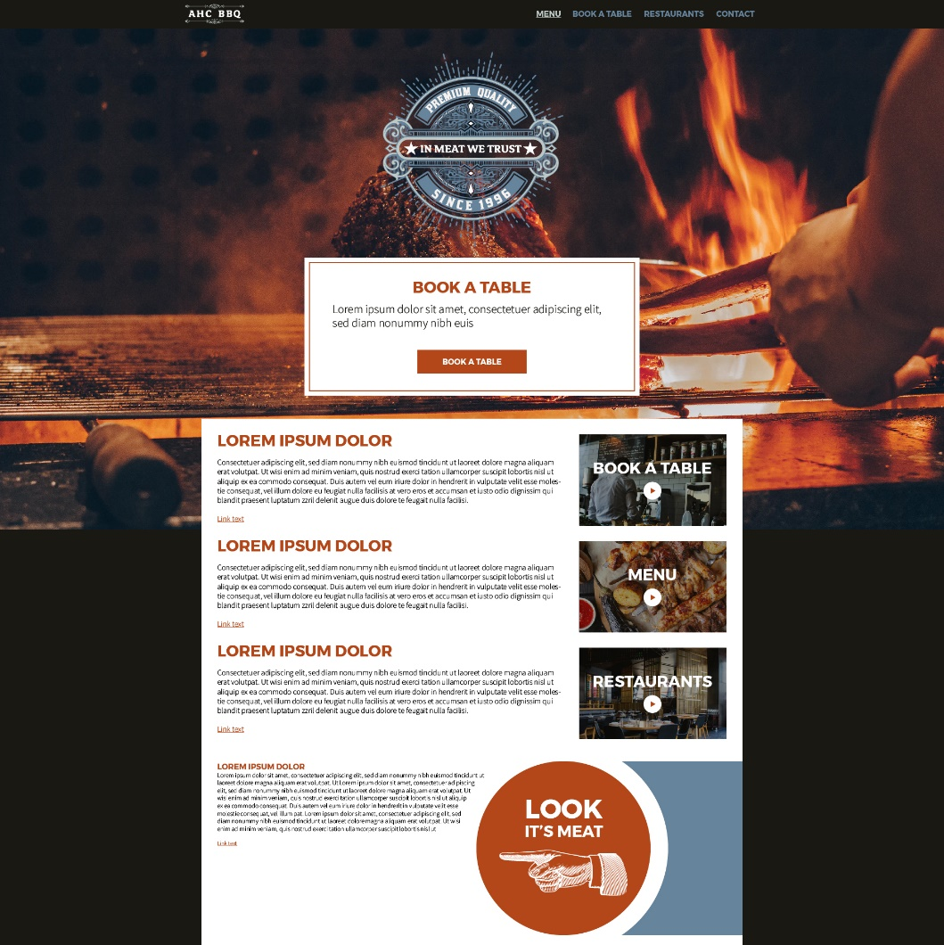Header and navigation font is Monserrat

Body text is source sans light

Nav links are #66849C

Selected state and hover is #BECAC7

The primary colour is #B44719

Body text, header and background is #1A1813